CSA1708-ARTIFICIAL INTELLIGENCE
LAB EXPERIMENTS
Program 8 : Python Program to Implement DFS
Aim
To implement Depth-First Search (DFS) and traverse a graph by exploring each branch before backtracking.
Algorithm
1. Create a graph and choose a starting node.
2. Mark the starting node as visited and display it.
3. Visit an unvisited neighbor recursively.
4. Backtrack when a node has no unvisited neighbors.
5. Continue until all reachable nodes are visited.
Program
graph = {
"A": ["B", "C"],
"B": ["D", "E"],
"C": ["F"],
"D": [], "E": [], "F": []
}

visited = set()

def dfs(node):
if node not in visited:
print(node, end=" ")
visited.add(node)

for neighbor in graph[node]:
dfs(neighbor)

dfs("A")
Sample Input
Starting node: A. The graph is defined in the program.
Program Execution
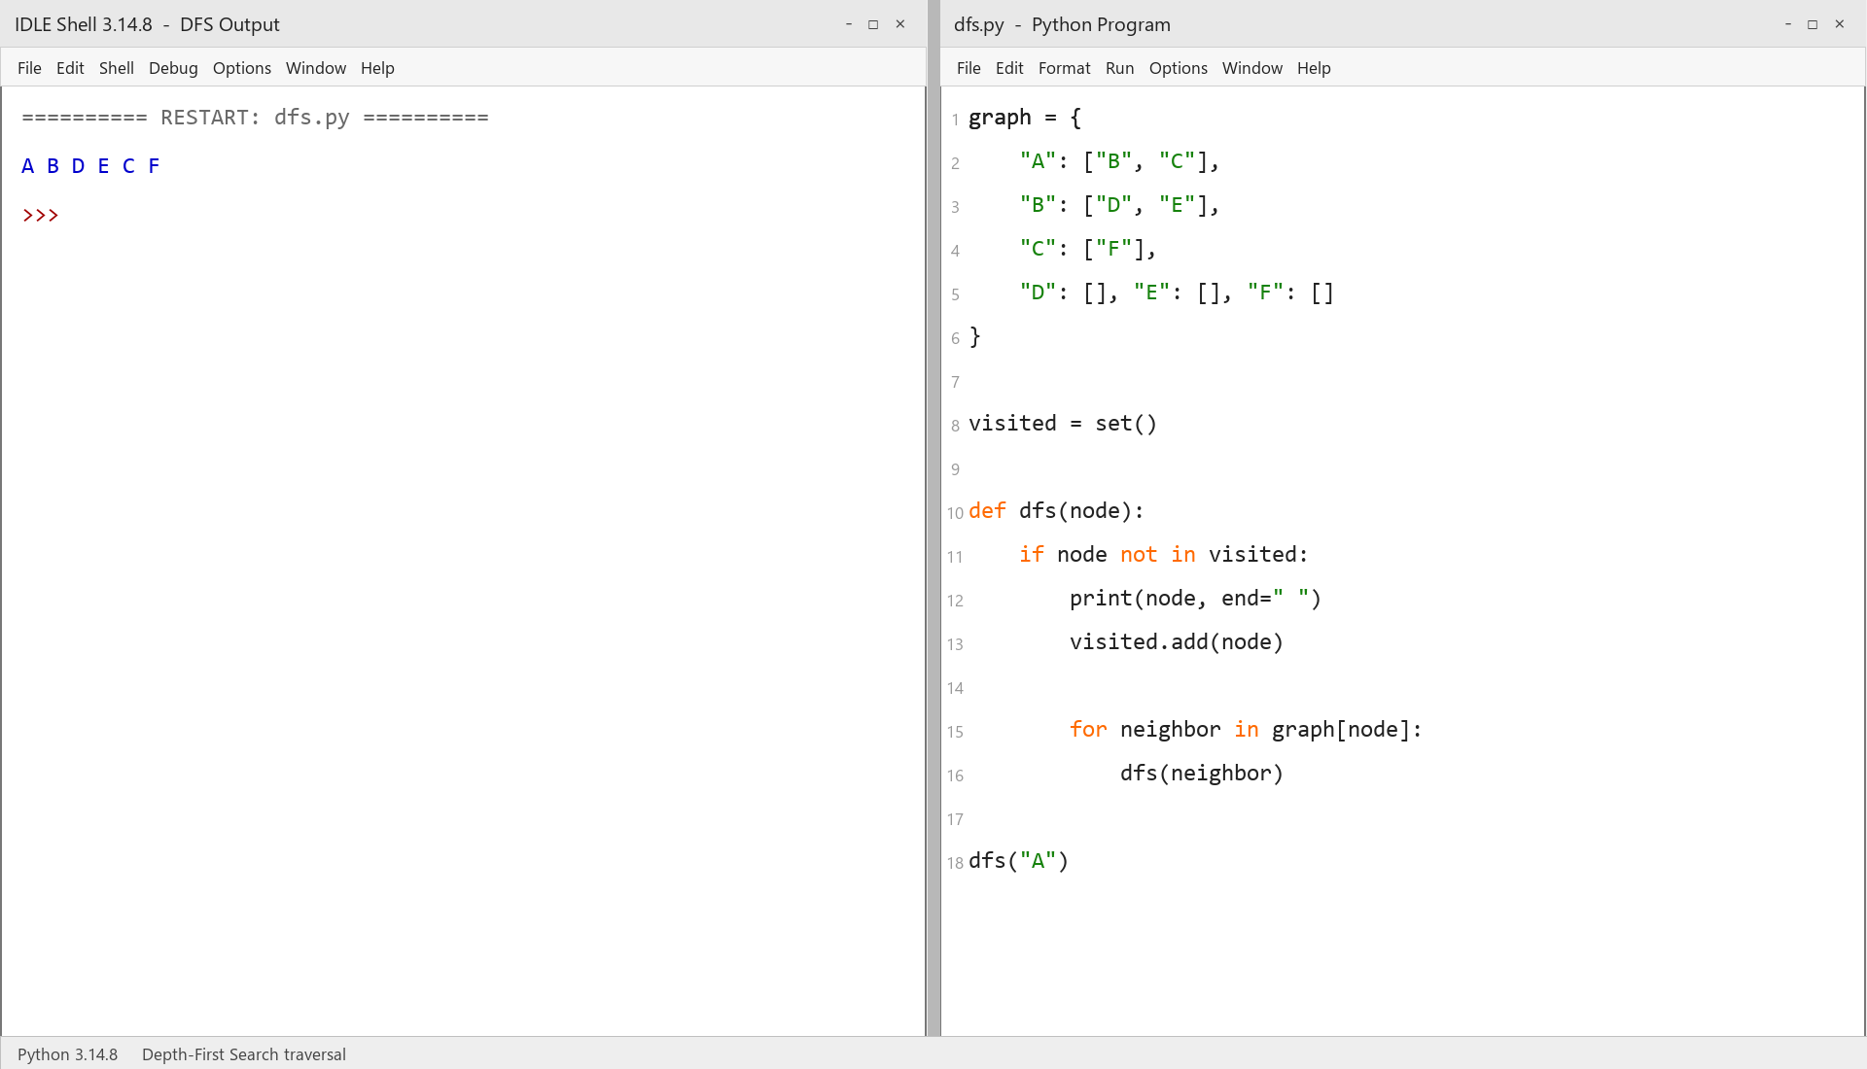
RESULT
Thus, graph traversal using DFS was implemented successfully using Python.

